**LAB 9**

* **Question 1:**
* Source code:

#include <stdio.h>

int prod(int a,int b)

{

int prod=a*b;

return prod;

}

int main()

{

int a,b;

printf("Enter 2 numbers: ");

scanf("%d%d",&a,&b);

printf("Product of numbers is: %d",prod(a,b));

}

* Output:

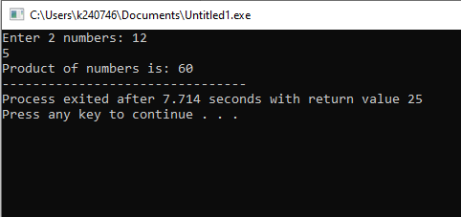

* **Question 2:**
* Source code:

#include <stdio.h>

void even_odd(int n)

{

if (n%2==0)

printf("Number is even");

else

printf("Number is odd");

}

int main()

{

int n;

printf("Enter a number: ");

scanf("%d",&n);

even_odd(n);

}

* Output:

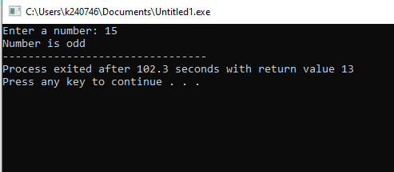

* **Question 3:**
* Source code:

#include <stdio.h>

#include <string.h>

int main()

{

char dest[20],src[20];

int n;

printf("Enter source string: ");

gets(src);

printf("Enter destination string: ");

gets(dest);

printf("Enter number of characters to append: ");

scanf("%d",&n);

printf("Concatenated string is: %s",strncat(dest, src, n));

}

* Output: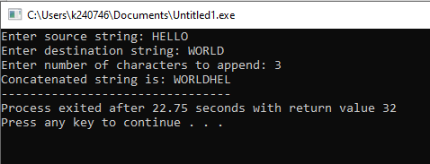
* **Question 4:**
* Source code:

#include <stdio.h>

#include <string.h>

int main()

{

char a[3][10]={{"Hello"},{"World"},{"Fast"}},s[10];

int i,found=0;

for (i=0;i<3;i++)

{

printf("%s",a[i]);

printf("\n");

}

printf("Enter a word to search: ");

gets(s);

for (i=0;i<3;i++)

{

if(strcmp(a[i],s)==0)

{

found =1;

break;

}

}

if(found)

printf("Your word has been founded!");

else

printf("Word not found");

}

* **Output:**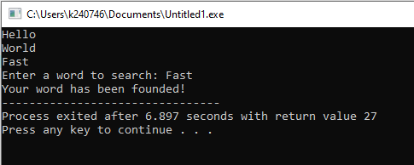
* **Question 5:**
* Source code:

#include <stdio.h>

void calculateFine(int dday,int dmonth,int dyear, int rday, int rmonth, int ryear)

{

int days1=dyear*365+dmonth*30+dday;

int days2=ryear*365+rmonth*30+rday;

int diff=days2-days1;

if(diff<=0)

printf("No fine!");

else

{

int fine=diff*2;

printf("Fine is $%d",fine);

}

}

int main()

{

int dday,dmonth,dyear,rday,rmonth,ryear;

printf("Enter due date\nDue year: ");

scanf("%d",&dyear);

printf("Due month: ");

scanf("%d",&dmonth);

printf("Due day: ");

scanf("%d",&dday);

printf("Enter return date\nReturn year: ");

scanf("%d",&ryear);

printf("Return month: ");

scanf("%d",&rmonth);

printf("Return day: ");

scanf("%d",&rday);

calculateFine(dday,dmonth,dyear,rday,rmonth,ryear);

}

* Output:

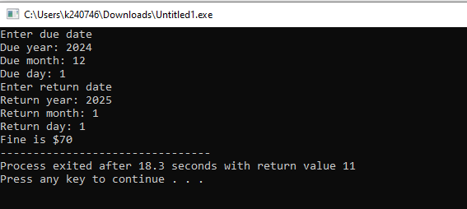

* **Question 6:**
* Source code:

#include <string.h>

#define MAX_WORDS 5

#define MAX_LENGTH 20

int isPalindrome (char word [MAX_LENGTH]) {

int len = strlen(word),i;

for (i = 0; i < len / 2; i++) {

if (word[i] != word [len-1-i]) {

return 0;

}

}

return 1;

}

int main() {

int i;

char words [MAX_WORDS] [MAX_LENGTH];

printf("Enter %d words (max %d characters each):\n", MAX_WORDS, MAX_LENGTH-1);

for (i = 0; i < MAX_WORDS; i++) {

printf("Word %d: ", i + 1);

scanf("%19s", words[i]);

}

for (i = 0; i < MAX_WORDS; i++) { if (isPalindrome (words[i])) {

printf("\"%s\" is a Palindrome.\n", words[i]);

} else {

printf("\"%s\" is Not a Palindrome.\n", words[i]);

}

}

return 0;

}

* Output:

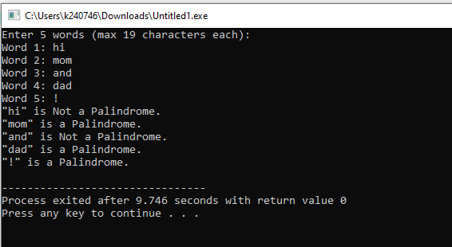

* **Question 7:**
* Source code:

#include <stdio.h>

void encryptMessage(char a[10], int n)

{

int i;

for (i = 0; a[i] != '\0'; i++)

{

if (a[i] >= 'A' && a[i] <= 'Z')

a[i] = ((a[i] - 'A' + n) % 26) + 'A';

else if (a[i] >= 'a' && a[i] <= 'z')

a[i] = ((a[i] - 'a' + n) % 26) + 'a';

}

printf("Encrypted message: %s\n", a);

}

void decryptMessage(char a[10], int n)

{

int i;

for (i = 0; a[i] != '\0'; i++)

{

if (a[i] >= 'A' && a[i] <= 'Z')

a[i] = ((a[i] - 'A' - n + 26) % 26) + 'A';

else if (a[i] >= 'a' && a[i] <= 'z')

a[i] = ((a[i] - 'a' - n + 26) % 26) + 'a';

}

printf("Decrypted message: %s\n", a);

}

int main()

{

char a[10];

int n;

printf("Enter a string (9 characters): ");

scanf("%s", a);

printf("Enter number of positions to shift: ");

scanf("%d", &n);

encryptMessage(a, n);

decryptMessage(a, n);

return 0;

}

* Output:

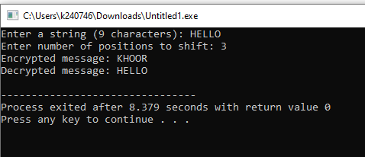

* **Question 8:**
* Source code:

#include <stdio.h>

void prime(int n)

{

int i,p=1;

for(i=2;i<n;i++)

{

if(n%i==0)

{

p=0;

break;

}

}

if(p)

printf("Number is prime");

else

printf("Number is not prime");

}

int main()

{

int n;

printf("Enter a number: ");

scanf("%d",&n);

prime(n);

}

* Output:

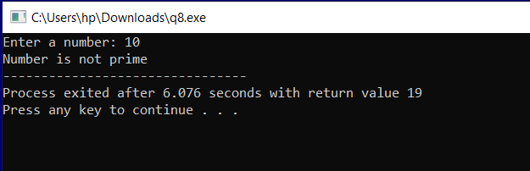

* **Question 9:**
* Source code:

#include <stdio.h>

int main() {

int size1, size2;

int *ptr, *ptr1, *ptr2;

printf("Enter size of first array (max 100): ");

scanf("%d", &size1);

int arr1[size1];

ptr=arr1;

printf("Enter elements of first array:\n");

for ( ptr = arr1 ; ptr < arr1 + size1; ptr++) {

scanf("%d", ptr);

}

int arr2[size2];

ptr=arr2;

printf("Enter size of second array (max 100): ");

scanf("%d", &size2);

printf("Enter elements of second array:\n");

for ( ptr = arr2 ; ptr < arr2 + size2; ptr++) {

scanf("%d", ptr);

}

printf("Common elements are:\n");

for (ptr1 = arr1; ptr1 < arr1 + size1; ptr1++) {

for (ptr2 = arr2; ptr2 < arr2 + size2; ptr2++) {

if (*ptr1 == *ptr2) {

printf("%d\n", *ptr1);

break;

}

}

}

return 0;

}

* Output:

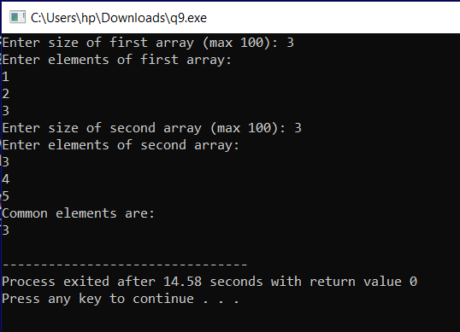

* **Question 10:**
* Source code:

#include <stdio.h>

#include <string.h>

char *reverse(char st[])

{

int len=strlen(st),i;

char temp;

for (i = 0; i < len / 2; i++)

{

temp = st[i];

st[i] = st[len - 1 - i];

st[len - 1 - i] = temp;

}

return st;

}

int main()

{

char st[100];

printf("Enter a string to reverse: ");

scanf("%s", st);

reverse(st);

printf("Reversed string: %s\n", st);

return 0;

}

* Output:

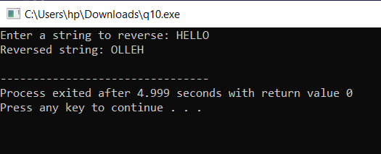

* **Question 11:**
* Source code:

#include <stdio.h>

#include <math.h>

int main()

{

float r,area;

printf("Enter radius of circle: ");

scanf("%f",&r);

area=M_PI*r*r;

printf("Area of circle is: %.3f",area);

}

* Output:

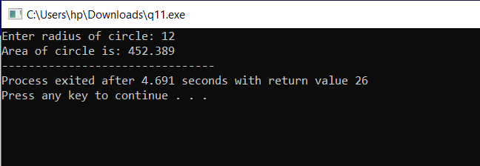

* **Question 12:**
* Source code:

#include <stdio.h>

int main()

{

int n;

printf("Enter size of array: ");

scanf("%d",&n);

int a[n],*ptr;

for (ptr=a;ptr<a+n;ptr++)

{

printf("Enter values: ");

scanf("%d",ptr);

}

int max=a[0],min=a[0];

for(ptr=a;ptr<a+n;ptr++)

{

if(*ptr>max)

max=*ptr;

if(*ptr<min)

min=*ptr;

}

printf("Maximum value is: %d\n",max);

printf("Minimum value is: %d\n",min);

}

* Output:

